Circuit Lab 2019 Regionals
Materials:
Station 1:
Station 2: 1 red, yellow, green & blue LED. Cover green LED with electrical tape to be the ‘mystery’, breadboard, 2 AA batteries, 1 AA battery holder, 1 multimeter
Station 3: 6 resistors: 100 Ω, 1 kΩ, 470 Ω, 47 Ω, + 2 others as red herrings. These exact resistances are important, but they need to be a factor of 10 apart. 1 bread board, 1 9V battery, 1 9V battery adapter, 1 multimeter
Station 4: Multimeter, 2 EKG pads, alcohol wipes
Station 1
You are trying to put together a circuit and you realize that you don’t have the right battery. You have only a 9 volt, and you need a six volt source. You have a set of supplies as listed below.
You have:
- As many wires as you like
- A breadboard
- Resistors: several of each of 500 Ω, 1 k Ω, 1.5 k Ω, 2 k Ω, 3 k Ω, 10 kΩ

Draw a circuit on your answer sheet that will allow you to have a six volt source.

Station 2
Measure the voltage across each of the unwrapped LEDs while they are lit. Record those voltages in the table on your answer sheet. (Which LED is number 1, 2, or 3 is not important.)
Now, measure the voltage across the mystery LED. Make a guess about which color that LED is on your answer sheet.
Explain your guess about the mystery color on your answer sheet.

Station 3
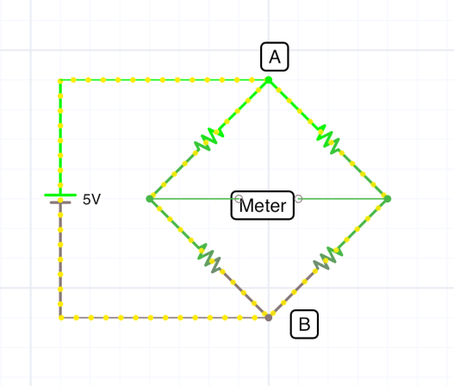
Using the materials provided, build a balanced Wheatstone bridge. Measure the voltage between points A and B. Record that voltage and the values of the resistors you used in the table on your answer sheet.
R1
R3

R4
R2

Station 4
At your station are some EKG pads. They are used to measure the voltage output of muscles. Using the alcohol pads, clean off the forearm of one of your teammates. Place pads on the arm and measure the voltage output as the person opens and closes their fist.
- Make a sketch of a circuit diagram on your answer sheet represents what you just did.
- Record the maximum voltage measured on your answer sheet.

