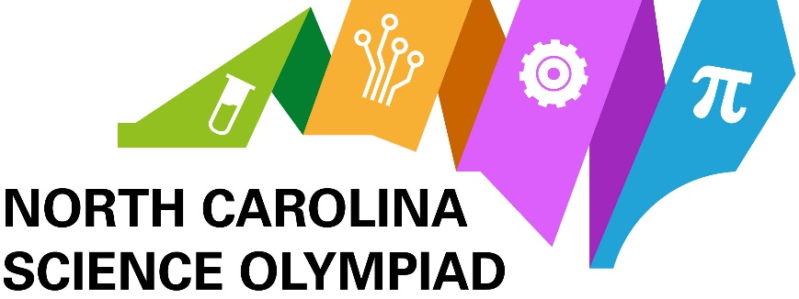
Assays & Techniques – Cell Biology Division C, 2022-2023

Below is a list of assays and techniques to know as per the rules. Here are some questions to consider:
- What is the purpose of each step and reagents used in the method?
- What information do they yield?
- When would the assay be used in an experiment?
- Which methods use antibodies, and what is the function of the antibodies?

Regionals and States:
Gel electrophoresis
- Agarose gel electrophoresis
- Polyacrylamide gel electrophoresis (PAGE)
  - Native PAGE
  - Non-reducing PAGE
  - Reducing PAGE
Western Blot (immunoblot)
ELISA
Immunoprecipitation (including Co-Immunoprecipitation)

